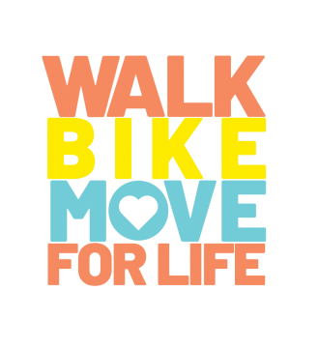

Dear Friends and Family,
On Saturday, November 2nd, I will be participating in Women’s Pregnancy Center’s 2019 Walk-Bike-Move for Life fundraiser, an event to raise funds to help women and men facing an unplanned pregnancy. Women’s Pregnancy Center has been serving our community for more than 38 years by engaging and informing women and men in unplanned pregnancies, empowering them to choose life! Each year, WPC serves nearly 2,000 clients providing compassionate care and no-cost services such as pregnancy testing, limited obstetrical ultrasound, options counseling and education, parenting support, mentoring and more.
At WPC, it takes approximately $300 to empower one mom to choose life for her unborn child. Would you consider giving to this ministry that is reaching women and men at a critical point of decision in their pregnancy?
My fundraising goal is of (insert your fundraising goal).
You can visit my personal fundraising page (insert link) to give to this life affirming organization.
To find out more about WPC, visit wpcocala.com. Thank you in advance for your support.

A copy of this email message is available at wpcocala.com/walk-bike-move

